**Project Name : Create A Social Media Post**

**1. INTRODUCTION**

**1.1 overview**

This is create a social media post .

**1.2 Purpose**

To bring valuable and entertaining content to other. .

**2. Problem Definition & Design Thinking**

**2.1 Empathy Map**

I had trouble gathering information on the Empathy Map. I show the empathy map.

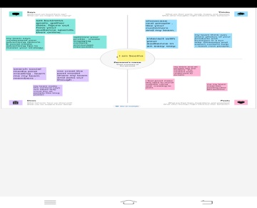

**2.2 Ideation& Brainstorming Map**

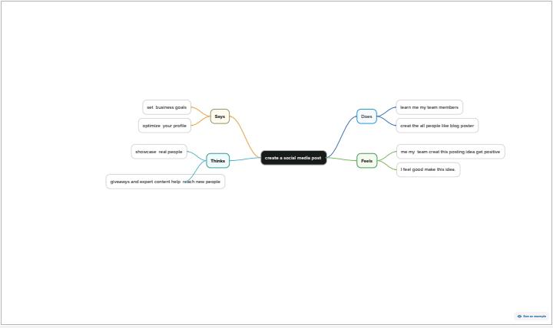

**3. Result**



**4.Advantage & Disadvantages**

It is useful for learn the designing skill for students.

It’s disadvantage is, it doesn’t the Practical Session.

**5.APPLICATION**

It’s so much useful for the student and non software worker Learn the designing skill.

**6.CONCLUSION**

We Learn a lot of new things about Editing and make post it useful for others.